Cold War Aircrew Forum 2010.

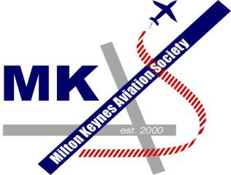

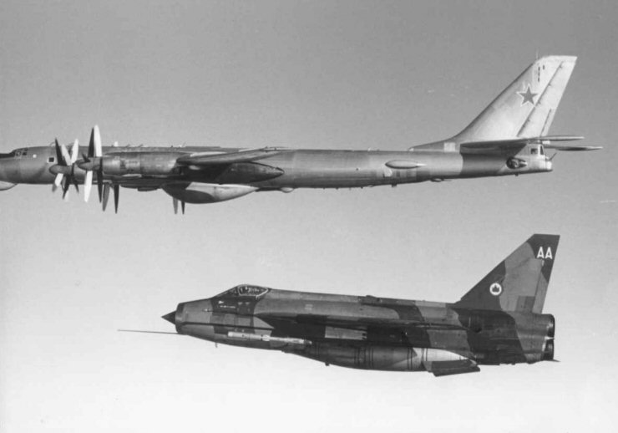

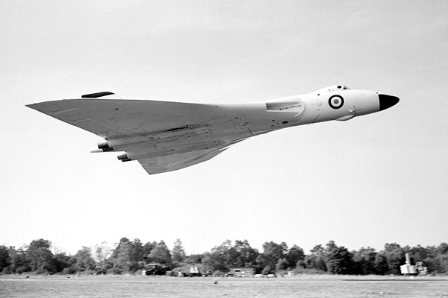

Tuesday 13th July 2010 - Another superb Aircrew Forum, the 4th one to date brought to you by MKAS.
We would like to sincerely thank our distinguished panel for their support and their wonderful anecdotes and to all the MKAS members and our guests, who supported the event and who took part in a thoroughly enjoyable evening in wonderful surroundings. Thank you all for your support and we hope you enjoyed the evening as much as we enjoyed staging it for your pleasure.
The Hunt House, Paulerspury, near Towcester, Northants NN12 7NA
On Tuesday 13th July 2010, MKAS staged our fourth aircrew forum, this time themed on the Cold War. I am pleased to report that the event was a tremendous success, with a sell-out audience enjoying the reminiscences of seven high calibre aviators who were active at the height of the Cold War.
The venue proved to be a great hit. The vast amount of memorabilia contained at The Sir Henry Royce Memorial Foundation kept everyone’s interest during the break and the period before the start of the forum. We were lucky that the original Rolls Royce Silver Ghost was in residence, together with a Royal Phantom IV. In the courtyard was a superb Silver Wraith standing next to the nose section of Lightning XS898. Luckily the afternoons rain eased off to allow a relaxed perusal of these exhibits and the rest of the memorabilia which consisted of many examples of early Royce electrical engineering, RR motor engines and RR aero & military engines. Our volunteers on the refreshments table were certainly kept busy during this time! It was also very gratifying that so many people supported the event by buying raffle tickets, programmes and other merchandise.
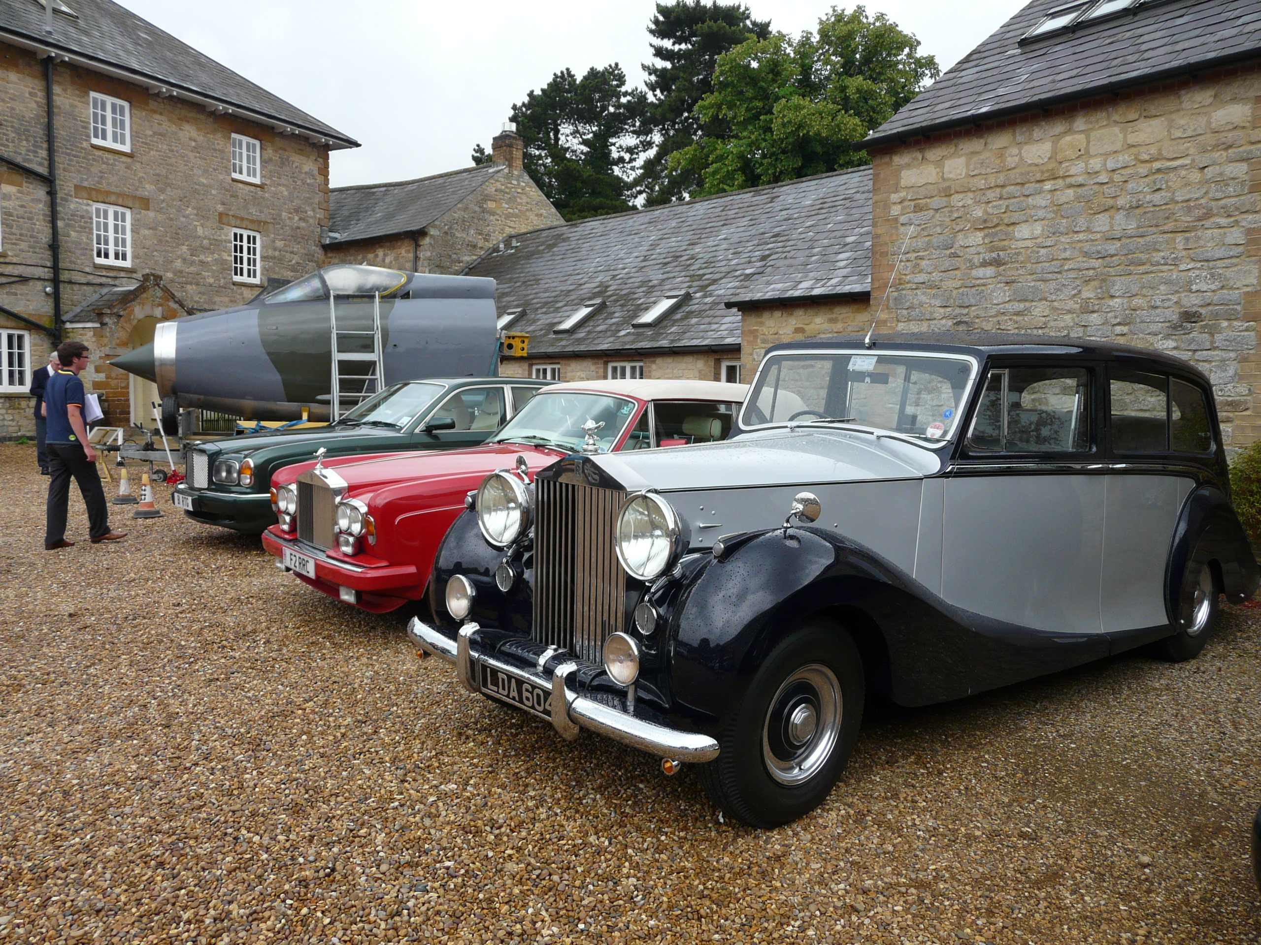
Courtyard with cars and Lightning cockpit (Ian Carr)
Andy Cornwell opened the forum by welcoming everyone and introducing our Chairman, Peter Dye. Peter has recently been appointed Director General of the RAF Museum, and we are grateful for the support given to the forum by the RAF Museum. Peter invited the panelists to introduce themselves in the following order:
Squadron Leader Pat Keating; Flight Lieutenant Arthur Creighton; Wing Commander Mike Streten; Air Vice-Marshal John Cliffe; Air Commodore Phil Wilkinson; Wing Commander Chris Reid; Squadron Leader Garry Garretts.
After a short video presentation on the Cold War museum at Cosford, Peter then directed a question of particular relevance to each panelist in turn. Our speakers then gave us some informative and entertaining answers to the following questions:
Pat Keating – “How do you think that Electronic Warfare developed over your time on the Vulcan force and especially up to the time when the Cold War ended in the early 90s?"
Arthur Creighton – “The Strategic Reconnaissance Valiants of No 543 squadron Royal Air Force were capable of operating in a variety of roles. How effective was the aircraft and it's equipment when used for maritime reconnaissance during the Cold War?”
Mike Streten – “Did the Russian aircrew on the Bears intercepted by the RAF understand English well and in real time?”
John Cliffe – “Recalling the pictures in the newspapers of Russian aircrew holding up Coca Cola cans when being photographed from a fighter, was intercepting Russian bombers really as relaxed as the pictures suggest?”
Phil Wilkinson – "What is the LABS manoeuvre; how was it carried out on the Canberra; how and where did you train for the 'real thing'?”
Chris Reid – "NATO maritime air defence must have needed a lot of international cooperation and agreements. What were the problems?"
Garry Garretts – "Having spent nearly six years fighting the Germans how is it that only three years after we were spending time, money and losing lives to feed them?"
If you want to know the answers to the above, then a DVD of the forum is available. There was a tremendous ambience on the panel, with much good hearted squadron rivalry and banter between the bomber and fighter contingents.
This interview session continued in to the second half, and sadly all too soon the end of the forum was in sight. Time only allowed for a few audience questions, before Andy asked Peter to draw the raffle and thanked all participants for their endeavours.
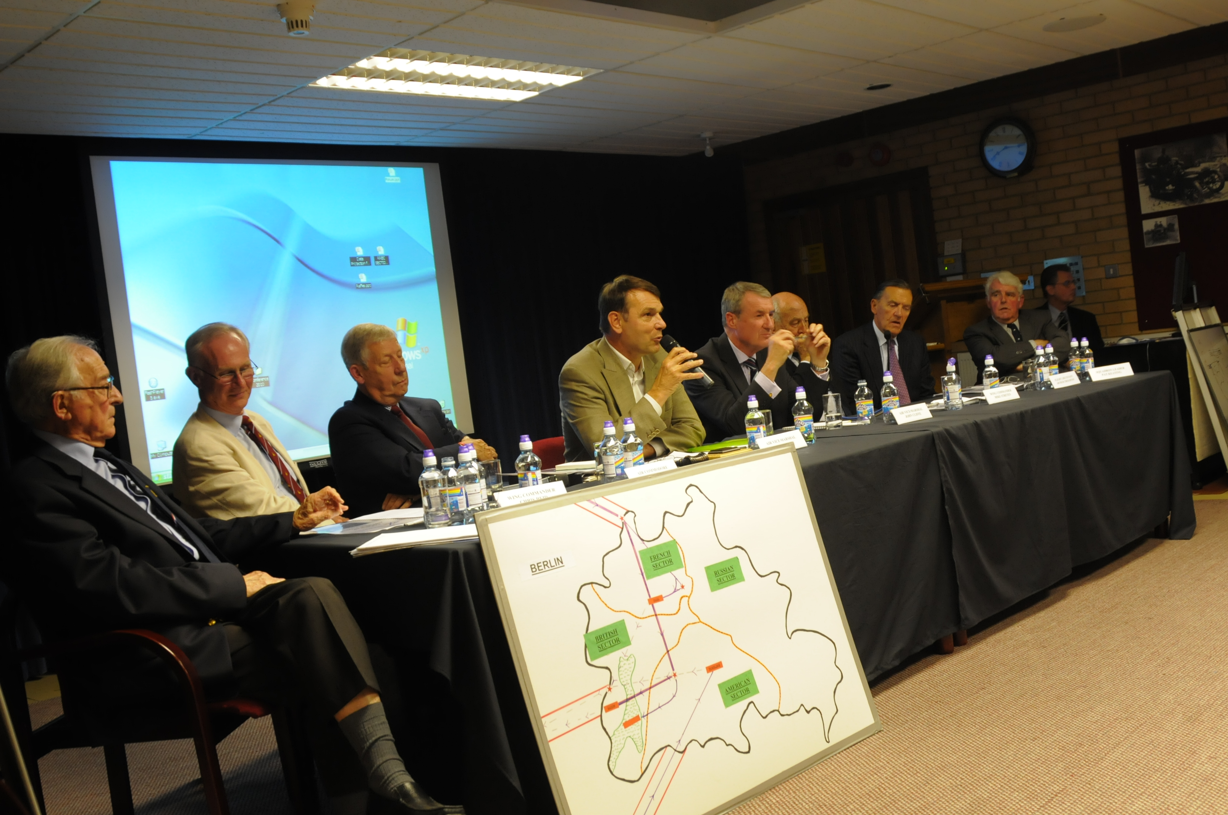
Aircrew Forum Panel (Richard Lambert)
In total we sold 108 tickets to the forum – 52 to MKAS members and 56 non MKAS. Including the panel and a handful of complimentary tickets we had over 120 people on the night. Thanks to all of you who supported it - this ensured we covered our costs, donated £400.00 to charity and had a thoroughly enjoyable evening.
I would like to take this opportunity to again thank everyone who helped out on the night – Andre Faehndrich, Peter Carter & Mike McEvoy on the door; Russell Osborn and Chris Bosworth in the car park; Ben Burt and Roy Dyer selling merchandise and raffle tickets; Andy Cornwell looking after the guests; Joan Harrington, Susan Carr, Mia Murray, William & Christopher Bishop on refreshments; Steven Murray and Michael Peters for AV and computer assistance. Thanks also to Steven for arranging the display of Rolls Royce cars, and to Frank and Tony Collins (no relation) for the presence of Lightning XS898.
I am grateful for the following organizations and individuals for their kind donation of raffle prizes – Jerry Knee; Andre Faehndrich; Mortons Media Group Ltd; Bletchley Park Trust; Ian Allan Aviation Tours; London Gliding Club; ModelZone; Ian Allan Plus and Joan Harrington.
Thanks of course to our panel, and our reserve speakers – Wing Commander Philip Goodall and Squadron Leader Dennis Brooks; our Chairman Peter Dye who did an exceptional job in keeping the evening flowing seamlessly; and the countless people who agreed to assist with my relentless quest for publicity. If I have forgotten anybody I humbly apologise.
We still have some programmes available for sale at £2.50 and of course the DVD which at £10.00 for nearly 2 ½ hours is great value. Several of our panel will also be giving lectures to us at our regular meetings next year on a range of fascinating topics, so please keep an eye on the website for details.
Ian Carr - Cold War Aircrew Forum Organiser

