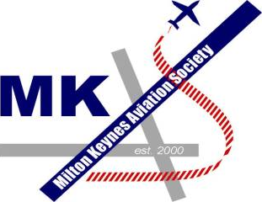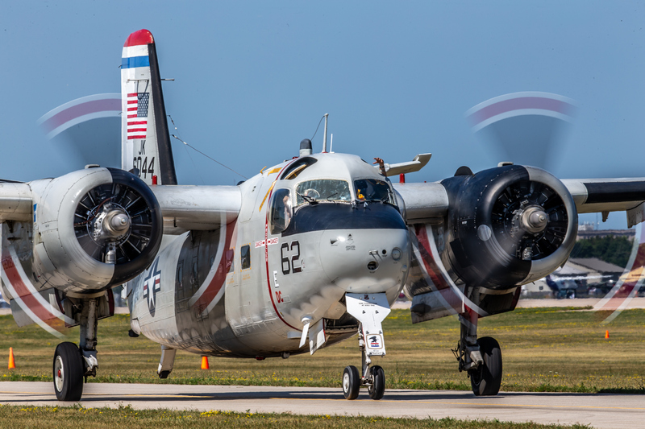
Milton Keynes Aviation Society 25th Annual Photographic Competition

Rules

Entries must be received not later than 11th February 2025

1. All entries will be displayed at our AGM meeting on Tuesday 11th March 2025.The competition is open to all paid up members of the Milton Keynes Aviation Society on this date.

2. Entries are to be made under the following categories:
A Best ground shot
B Best flying shot
C Most unusual shot
D “The Spirit of Aviation” - (not necessarily an aircraft)
E Caption competition – any aviation related subject with a witty caption.
F The rarest aircraft you saw last year
G Down Memory Lane – a return to the days of the “Martini” shot – any aviation photograph taken before 2015 which brings back happy memories

Best photograph overall will be chosen from the winners of categories A to D.
NB: Air-to-air photographs are not eligible in categories A to D. With the exception of category G, photographs must have been taken between 01/01/2024 and 31/12/2024.

4. There is no entry fee to submit photographs for this Competition.

5. Entries should be submitted in digital (JPEG) form and can be handed over/posted on a disk/memory stick or can be sent by e-mail (preferably just a few at a time) to cj.bos@ntlworld.com. All e-mail entries will receive an acknowledgment that they have been received safely. If you do not receive this acknowledgment, then please phone Chris Bosworth on 07860 629494 to confirm receipt.

6. Each photograph must be labelled with the member’s name and the category entered (failure to do so may result in the entry being rejected), e.g. BOSWORTH A-1, BOSWORTH A-2, etc

7. A member may enter up to 20 photographs across categories A-D with a maximum of 10 in any individual category. A further 8 may be added in categories, E, F and/or G beyond this maximum, i.e. 28 in total. By entering their images, they agree to the use of them in any MKAS publications, on the MKAS website and in any MKAS social media networks.

8. Work entered in a previous MKAS Photographic Competition is not eligible for entry in any category.

9. Winners will be chosen by an independent judge who is not a member of MKAS. In the event of a dispute, the judge’s decision is final.

10. Whilst every care will be taken with material submitted, the Society cannot be held responsible for any damage.

11. All images must have been taken by the person submitting the entry - third-party images from any source are strictly forbidden. Images may be edited to enhance the finished result but advanced post-processing which fundamentally changes the original image as taken, such as (but not limited to) sky replacement, combining multiple images and the addition of effects/items not present at the time of exposure, are not allowed.

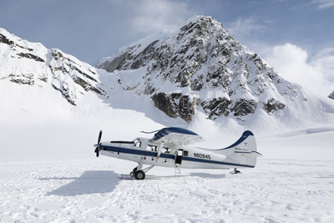

Milton Keynes Aviation Society

25th Annual Photographic Competition
Entry Form

Entries must be received not later than 11th February 2025

The winner of the ‘Best Photograph Overall,’ will be awarded the
trophy (to be held for one year) and the winning photograph will appear on the front page of the MKAS newsletter.

Certificates will be awarded to the winner and up to 3 commendations in each category.

No fee will be charged to enter this competition.

Name……………………………………………………….

Telephone number…………………………… E-mail…………………………………………..

I wish to enter photographs in the following categories:
(Please state number of photographs entered in each category - MAXIMUM is 20 across categories A-D, of which a maximum of 10 can be entered in any one category plus an additional 8 in Categories E, F and/or G making 28 overall)

Number of entries
A – Best ground shot of any aircraft

B – Best flying shot of any aircraft

C – Most unusual shot

D - ‘The Spirit of Aviation’ (not necessarily an aircraft)
E - Caption competition – any aviation related subject with a witty caption
F – The rarest aircraft you saw last year
G - Down Memory Lane – Any aviation photograph taken prior to 2015 which brings back happy memories

Best photograph overall will be chosen from the winners of categories A-D.

Please return this form, with your entries to the Competition Secretary: Chris Bosworth, 23 Phoenix Close, Leighton Buzzard, Beds, LU7 3YW (cj.bos@ntlworld.com) or by hand at the January or February MKAS lectures.

